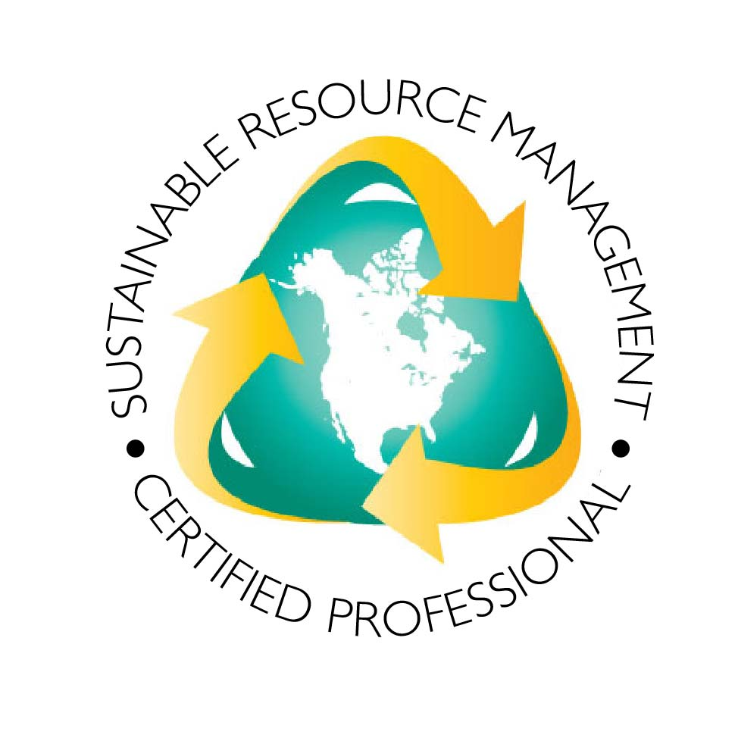

Greetings Recycling Organization Leaders:

We are requesting your help as a recycling leader, to advance training and certification in your state and the nation. If you support professionalizing the recycling sector and increasing safety, building credibility, and expanding career horizons, then please contribute a letter to assist your National Recycling Coalition (NRC). Your letter will help raise funds to fully deploy what we have developed over the past five years.

The NRC’s National Standards Certification Board has developed a set of guidelines to certify organizations to train, implement, and improve recycling. So far, New Mexico, New Jersey and Pennsylvania’s training programs have been accredited, with an application pending from Illinois. Please help us build capacity to serve every state wanting to boost recycling and sustainable resource management.

Learning outcomes achieved through the certification program include: a command of the technical language and the tools employed to eliminate waste, reuse products and packaging, and use resources efficiently; ability to incorporate applicable laws, regulations and policies; economically sound business practices; health and safety regulations and incorporation of best practices into everyday resource management work; and, developing effective outreach campaign strategies and techniques to support and measure local economic development and job creation.

This certification, from an accrediting college or university, not only provides valuable training, but identifies qualified professionals who are committed to excellence in the field as well.

Your Letter of Interest simply states your entity is interested in developing training and certification and outlines what your ideal time frame would be to develop and launch that program. We have included a draft letter for you to place on your letterhead.

Until that time, we hope reach out to all state and regional ROs, provide information, and offer presentations to boards. We will connect further in May at the Sustainable Materials Management Summit in Washington, DC. We encourage you to visit our website: <http://nrcrecycles.org/national-standards-certification-board/> or contact us if you need additional information or have questions or comments: NSCB@NRCrecycles.org

Thank you for supporting recycling!

NRC’s National Standards Certification Board:

English Bird, New Mexico Recycling Coalition

Lisa Friend, Boulder County (CO) Sustainability Office

MaryEllen Etienne, Reuse Institute and REUSE.International

John Frederick, NSCB Chair and NRC Board

Judi Gregory, NSCB Secretary and Go2Zero Strategies

Bert Jacobson, Kankakee Community College, Illinois and the Illinois Recycling Association

Marie Kruzan, Association of New Jersey Recyclers

Gary Liss, Grassroots Recycling Network and NRC Board

Joanne Shafer, Centre County Recycling and Refuse Authority, Pennsylvania and Professional Recyclers of Pennsylvania

Jack DeBell, University of Colorado, NRC Board and Project Manager

Date

NRC Fund Development

National Recycling Coalition

1220 L St NW

Suite 100-155

Washington, DC 20005

Email letter directly to:

[laura@nrcrecycles.org](mailto:laura@nrcrecycles.org)

[NSCB@nrcrecycles.org](mailto:NSCB@nrcrecycles.org)

Dear NRC Fund Development Committee,

As recycling leaders, we support training and certification as an investment in the professionalization of the recycling sector. Most trade organizations provide professional certification to benefit states. It’s time for the recycling sector to help states develop theirs. Trained professionals build credibility for our industry, increase safety, develop avenues for advocacy and expand participants’ professional horizons.

The [INSERT ENTITY NAME] is interested in offering a nationally accredited recycling professionals certification program within the next year [specify expected timeline to develop/launch].

Our entity is interested in benefitting from other accredited state programs that have offered to share expertise, mentoring, and their curriculum to support growth of new programs. The NRC Fund Development Committee, the NRC National Standards Certification Board and the NRC Campus Council will provide these supportive services.

Please send me more information about the respective services your entity would like to receive:

 Mentoring To Assist in Program Development

 Provision of Sample Curriculum From Existing Trainings

 Funding Assistance Through National Grant Writing Effort

Best regards,

Name, Title